Zachery Fogg, Clayton Chisholm, Kevin Veronneau

10/8/2021

CS 275

**Final Project: Initial Deliverable**

**High level description**:

Our project idea is a game suite app. We currently plan on making 6 unique game, 2 games per developer. We plan on using Sprite Kit for development. Each game is meant to be played by two people on the same phone; in this example photo, the hands belong to two different people and they each control one of the characters on the screen using the blue and red buttons respectively:

Games will use roughly the same art style (maybe custom pixel art, or maybe assets from an asset pack that meets our needs). Games will have roughly the same controls, same score counter location, same menu button location.

When the app loads, the game menu will be the initial view:

The game menu will display all the available games, whose icons will be clickable. A detailed settings menu will likely not be needed, only the ability to mute and unmute sound; we may find a need for a detailed settings menu as we start development.

Below are preliminary sketches for the six games we plan to develop:

Kevin:

Zachery:

Clayton:

Each game will display the same menu once a win condition has been met.

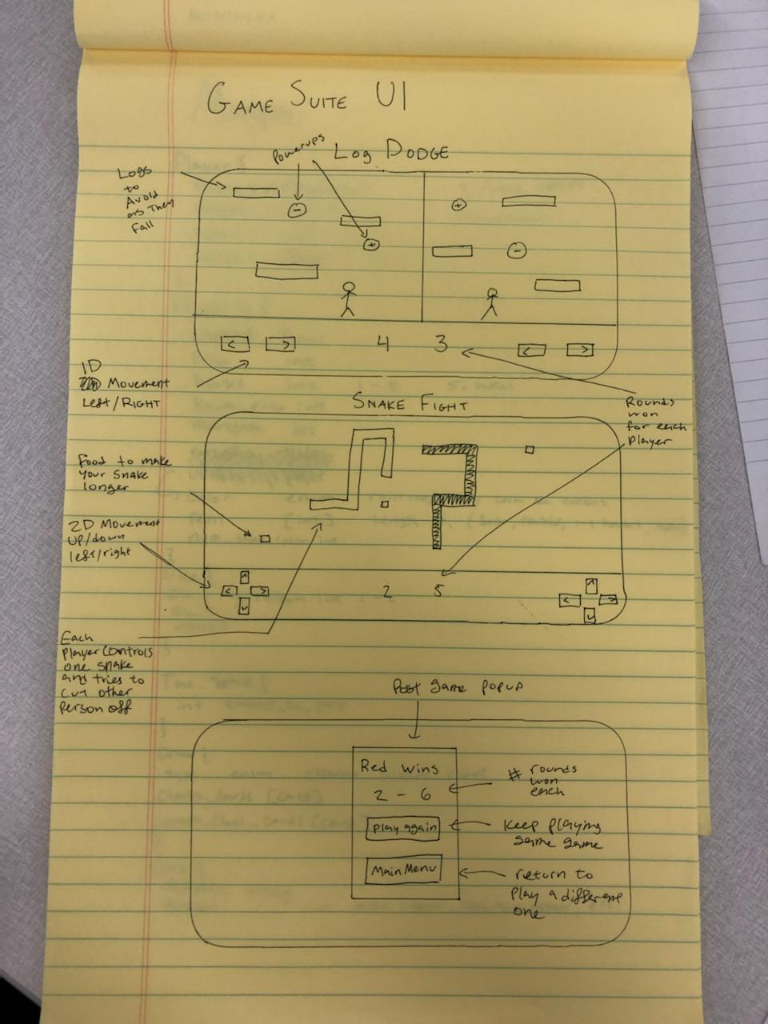

Each game will share many of the same components (controls, score counter, menu Button) and will all display only in landscape mode.

From these pictures quite a few reusable components can be intuited: user input controls, game containing views, ending menus, score board, menu buttons, player models, projectile models (three games shown above could use the same bullet model).

We haven’t discussed specific requirements at this point, but quite a few requirements can be ruled out: user data persistence, internet connectivity, phone camera use. Our first steps will be to create the initial start menu and shared components (score board, game controls, post-game menu) together; we hope to have these completed by the November 1st. Once we have a framework for our games to sit in, we will individually develop each of our two games.